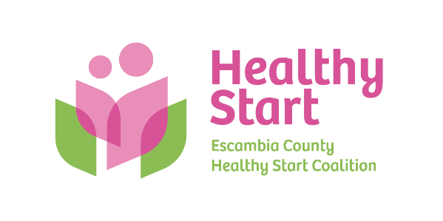
Escambia County Healthy Start Coalition Inc.,
318 N. Alcaniz Street | Pensacola Florida | 32501
P: 850-696-2291, F: 850-696-2551

Board of Directors

Meeting Minutes: November 20, 2025
Board Members Present: Margot Lauro, Kevin Driscoll, Russell Williams, Robin Wright, Diane Schwartz, Jaclyn Havinga, Ander Shimek, Beth Skarda. (8 present). Attending via Zoom: Judge Nickinson
Also Attending: Allyson Anderson, Chris Hall
Not Attending: Julie DeCesare, Janet Garrett, Rainey Brown
- Call to order – Margot called the meeting to order at 5:30 PM and welcomed new Board member, Beth Skarda.
- Quorum (Requires 7/12 Current Members) – 8 Board members attended in-person. Quorum was established.
- Mission Moment – Allyson spoke about the Coalition’s recent work to provide approximately 50 food bags to Healthy Start clients in need during the federal government shutdown and suspension of SNAP benefits, disproportionately impacting our clients. A variety of healthy shelf-stable food items were purchased for clients and distributed by our Care Coordinators at DOH. Allyson then introduced Fatherhood Coordinator Chris Hall, who shared his background and work with fathers in our program. Chris is doing a wonderful job with this program and is building it through sustained and ongoing outreach to be successful.
- Ratification of Minutes – The October 16, 2025 meeting minutes were reviewed by the members present and accepted as written, with a motion to approve made by Kevin.
- Board Business:
- Finance: October, 2025 Financial Statements and Reports – Kevin presented the October financial statements and reports to the Board, noting that DOH is now current with payments, and HSMN’s payments are on its typical 2-month receivable pattern. Kevin also stated that our annual Warren Averett is underway now, and that we expect their representative to attend January’s Board meeting to share their report.
- FIMR (CRT)/IMTF (CAG): Margot shared about the recent Maternal Health Task Force meeting led by Representative Salzman and with many CEO-level professionals in attendance, noting that Claire represented FIMR and Healthy Start well and with deep command of the data on the issues being discussed. Claire has since had high level data meetings with Task Force members, with the next meeting scheduled for December 15. In addition, Claire will be Quint Studer’s guest on an upcoming segment of Blab TV.

- Bow Ties & Tiaras – Margot shared that our Bow Ties & Tiaras theme will be retired for 2026, having run its course. The Committee and all Board members are encouraged to provide their ideas and insight on a suitable new theme for the event. Venue has been secured for 2026, taking place again at 5eleven Palafox on Thursday, May 1 from 5:30 PM to 8:00 PM. The event Committee met with John Peacock earlier this month, and he provided helpful insights on how we can be even more successful at future events.

- Executive Director Report:
- Trunk or Treat – Over 200 guests in attendance. The event continues to grow and be successful.
- North Escambia Stork Stock - Ceremonial re-opening plans are in progress with date TBD.
- IMPACT 100 – Implementation is on track.
- Escambia Children’s Trust – Implementation also on track.
- PSC Non-Profit Certification Program – Allyson updated the Board on the “paused” status of this program. Allyson will remain informed of PSC Non-Profit subject matter competency training opportunities and keep the Board informed as well.
- Events:
- 2026 North Escambia Baby Shower – Saturday, April 18, 2026 from 10:00 AM – 1:00 PM (Century Community Center)
- Staff Attendance at Board Meetings – 02/19 - Keila; 03/19 - Jade; 04/16 – Megan; 05/21 - Sarah

- New Business – (1) Sunshine Law training – Our goal is scheduling for January Board meeting, depending on presenter availability. Meredith Bush will be our expert presenter.
- Adjourn – The meeting adjourned at 6:26 P.M.
- Next Meeting – Thursday, January 15, 2026 at 5:30 PM at the Healthy Start office.

