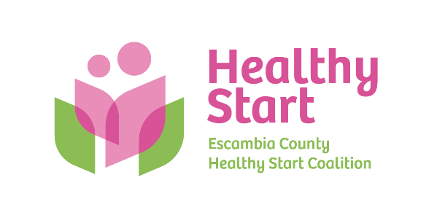
Escambia County Healthy Start Coalition Inc.,
318 N. Alcaniz Street | Pensacola Florida | 32501
P: 850-696-2291, F: 850-696-2551

Board of Directors Meeting Agenda

May 21, 2026
- Call to order
- Quorum (7/12 voting members)
- Mission Moment – Allyson Anderson
- Acceptance of Minutes – March 19, 2026 Meeting Minutes
- Board Business:
- Finance: (1) April Financial Statements & Reports; (2) Case Management System – Revenue Impacts; (3) FY 2026-2027 Budget Update & Vote - Kevin Driscoll
- FIMR/Community Action Group (CAG) Updates – Claire Kirchharr-Hudson
- Cocktails For Cradles – Event Committee
- Bylaws Committee Update – (1) Updated Bylaws (vote); (2) Term Limits (Maximum of two 3-year terms + unexpired term of no longer than 1 year of any member being replaced, if applicable); (3) Advisory Board (Membership Workgroup – Fall Target); (4) Board Secretary (Roles/Duties, Member to fill) - Committee: Judge Nickinson, Ander Shimek, & Robin Wright
- Executive Director Report – Allyson Anderson
- Retreat Summary and Next Steps – Margot Lauro

- Next Meeting: Thursday, June 18, 2026 @ 5:30 P.M.

- Adjourn

