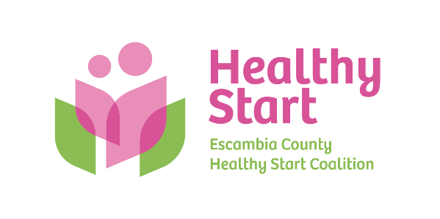
Escambia County Healthy Start Coalition Inc.,
318 N. Alcaniz Street | Pensacola Florida | 32501
P: 850-696-2291, F: 850-696-2551

Board of Directors Meeting Agenda

January 15, 2026

- Call to order
- Quorum (7/12 voting members)
- Welcome New Members – Julie DeCesare, M.D. (Updated Roster)
- Mission Moment – Allyson Anderson
- Acceptance of Minutes – November 20, 2025 Meeting Minutes
- Board Business:
- Finance: December, 2025 Financial Statements & Reports - Kevin Driscoll
- FIMR/IMTF (Community Action Group: CAG) Updates – Allyson
- Annual Fundraiser – Event Committee
- Vision & Mission Committee Update – Schedule Retreat
- Executive Director Report – Allyson Anderson
- Unfinished Business: Sunshine Law Training
- Next Meeting: Thursday, February 19, 2026 @ 5:30 P.M.

- Adjourn

