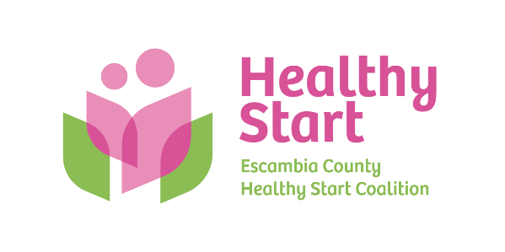
Escambia County Healthy Start Coalition Inc.,
318 N. Alcaniz Street | Pensacola Florida | 32501
P: 850-696-2291, F: 850-696-2551

Board of Directors

Meeting Minutes: January 15, 2026
Board Members Present: Margot Lauro, Janet Garrett, Kevin Driscoll, Russell Williams, Robin Wright, Diane Schwartz, Rainey Brown, Jaclyn Havinga, Dr. Julie DeCesare, Ander Shimek, Judge Nickinson, (11 present). Also Attending in-Person: Allyson Anderson, Lakeila Robertson, Dr. Ramak Amjad
Attending via Zoom: Kristen McAllister & Lindsey Zajac (Warren Averett), Beth Skarda, Barbara Shoulders
- Call to order – Margot called the meeting to order at 5:30 PM and welcomed new Board member Dr. Julie DeCesare.
- Quorum (Requires 7/12 Current Members) – 11 Board members attended in-person. Quorum was established.
- Mission Moment – Allyson spoke about the Coalition’s recent reopening of our North Escambia Stork Stock in Century at the CHNWF site, and recent media coverage in Bella Magazine, PNJ, and NorthEscambia.com. She also recognized Community Liaison Keila Robertson’s passionate work in service to all families, and especially those in North Escambia. Keila shared her enthusiasm for her work and nearly 5 years of service to Healthy Start.
- Ratification of Minutes – The November 2025 meeting minutes required 1 correction to the date of our 2026 fundraising event from May 1 to October 1. The Minutes were then accepted with that correction noted, with a motion to approve made and then seconded by Diane and Kevin, respectively.
- Board Business:
- Audit Report Presentation – Kristen McAllister and Lindey Zajac presented the Warren Averett audit report, with no findings or irregularities noted. Kevin made a motion to approve their report as presented, with Ander as a second. All voted in favor of approving the Warren Averett audit report.
- Finance: December, 2025 Financial Statements and Reports – Kevin presented the December financial statements and reports to the Board, noting that DOH has 1 month of receivables due to the Coalition, while HSMN’s payments are on their standard 2-month receivable pattern. Allyson then reported that all automated deposits and drafts have now been moved to the new bank, Hancock Whitney, and we will be closing the Renasant account prior to the next Board meeting.
- FIMR (CRT)/IMTF (CAG): Allyson presented the January FIMR CRT report, highlighting 3 reviewed cases and findings. Dr. Amjad then spoke to his desire to resume meetings of the Infant Mortality Task Force, now contractually known as Community Action Group (CAG) and whose work is more prescribed under contract terms and statute. This work continues and is well underway, while also supporting the Maternal Health Task Force effort led by Representative Salzman and Quint Studer. Claire is leading much of our participation as a trusted resource with deep command of the data and issues being discussed. Further discussion may continue at the upcoming Retreat.
- Annual Fundraiser – Margot shared that our Bow Ties & Tiaras theme has been retired, with Cocktails and Cradles now positioned as our theme and fundraising future. The event takes place again at 5eleven Palafox (inside and outdoor courtyard space) on Thursday, October 1 from 5:30 PM to 8:00 PM. John Peacock will be invited as this year’s emcee.
- Executive Director Report:
- IMPACT 100 – Implementation is on track.
- Escambia Children’s Trust – Implementation also on track.
- Upcoming Dates/Events:
  - Saturday, January 31, 9:00 AM-12:00/1:00 PM – Board Retreat at Ronald McDonald House

  - Thursday, February 19 Board Meeting, 5:30 PM – Sunshine Law Training

  - Saturday, April 18, 10:00 AM-1:00 PM – North Escambia Baby Shower @ Century Community Center

  - Thursday, May 21 Board Meeting, 5:30 PM – Vote on proposed FY 2026-2027 budget

  - Thursday, October 1, 5:30-8:00 PM – Cocktails & Cradles annual fundraiser @ 5eleven

  - Thursday, October 15, 6:00-7:00 PM – National Pregnancy & Infant Loss @ Bayview Park

  - Thursday, October 22, 4:30-6:30 PM – Trunk or Treat @ Alcaniz field space

- New Business – Sunshine Law training – Takes place at our February 19 Board meeting.
- Adjourn – The meeting adjourned at 6:30 P.M.
- Next Meeting – Thursday, February 19 at 5:30 PM at the Healthy Start office.

