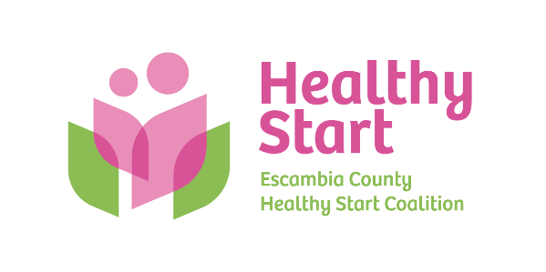
Escambia County Healthy Start Coalition Inc.,
318 N. Alcaniz Street | Pensacola Florida | 32501
P: 850-696-2291, F: 850-696-2551

Board of Directors Meeting Agenda

February 19, 2026

- Call to order
- Quorum (7/12 voting members)
- Mission Moment – Allyson Anderson
- Acceptance of Minutes – January 15, 2026 Meeting Minutes
- Board Business:
- Sunshine Law Training – Meredith Bush, Esq.
- Finance: January Financial Statements & Reports - Kevin Driscoll
- FIMR/IMTF (Community Action Group: CAG) Updates – Allyson
- Cocktails & Cradles – Event Committee
- Retreat Recap – Margot Lauro
- Executive Director Report – Allyson Anderson
- Next Meeting: Thursday, March 19, 2026 @ 5:30 P.M.

- Adjourn

