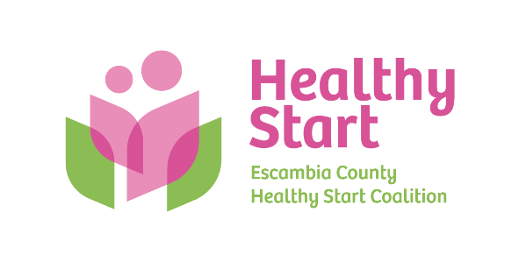
Escambia County Healthy Start Coalition Inc.,
318 N. Alcaniz Street | Pensacola Florida | 32501
P: 850-696-2291, F: 850-696-2551

Board of Directors

Meeting Minutes: May 21, 2026
Board Members Present: Margot Lauro, Janet Garrett, Kevin Driscoll, Rainey Brown, Robin Wright, Judge Nickinson, Diane Schwartz, Dr. Julie DeCesare (8 present).
Also Attending in-Person: Allyson Anderson, Claire Kirchharr-Hudson Attending via Zoom: None
Absent: Beth Skarda. Ander Shimek, Russell Williams, Dr. Jaclyn Havinga,
- Call to order – Margot called the meeting to order at 5:31 PM.
- Quorum (Requires 7/12 Current Members) – 8 Board members attended in-person. Quorum was established.
- Mission Moment – Allyson spoke about a recent success story in our Fatherhood program in which a dad communicated with Chris about his pending reunification with his child and expressed his gratitude for all Chris had done to make it possible. Allyson also spoke with pride about the team’s recent success at its North Escambia Baby Shower.
- Ratification of Minutes – Approval of the March 2026 Meeting Minutes, with motion and second by Janet and Robin, respectively. There was no April meeting due to baby shower activities and travel.
- Board Business:
- Finance: – (1) April Financials - Kevin presented the April financial statements to the Board, noting that despite a single month of disappointing HMSN earnings due to our case management system outage, the fiscal year-end is approaching, and we are within budget and on track to finish with a strong year-end. (2) Proposed FY 2026-2027 Budget – Allyson previously shared several versions of the budget, including one draft that included the state’s proposed $66,000 reduction in funding for Escambia. Fortunately, that scenario did not happen and we are level-funded for the upcoming fiscal year. The Board voted to pass the proposed budget with a 3% salary increase for staff, with a motion and second by Kevin and Ed Nickinson, respectively.
- FIMR (CRT)/IMTF (CAG): Claire shared our May FIMR report and summarized Rep. Salzman’s recent task force meeting on April 10, 2026, noting the Task Force’s work will focus its work on improving outcomes in the 32505 zip code. Our upcoming Service Delivery Plan is nearing completion ad will reflect recommendations from the Board, as well as our FIMR CRT and other stakeholders.
- Cocktails for Cradles Committee – Margot shared the newly approved Cocktails for Cradles sponsorship packet and encouraged all Board members to support our signature fundraising event as donors and sponsors, while also sharing our sponsorship proposal with community members and partners. The committee also seeks the Board’s help in securing auction items, with a focus on experiences that are hoped to generate interest and donations.
- Bylaws Committee – Tabled until June 18 meeting.
- Executive Director Report: Allyson noted key items, including: a favorable DOH monitoring report; our new monthly Impact Report (to be cumulative each calendar year); completing our Escambia Children’s Trust grant, winding down our IMPACT 100 grant, future grant writing plans, and elevator pitches/PowerPoint, along with future event dates. In addition, Dr. DeCesare indicated her willingness to assist with Ladies First screening challenges, while the Board approved our new Case Management System Disaster and Recovery Policy.
- Upcoming Dates/Events:
  - Saturday, June 27, 10:00 AM-12:00 PM – Pops & Tots @ Legion Field

  - Thursday, October 1, 5:30-8:00 PM – Cocktails & Cradles annual fundraiser @ 5eleven

  - Thursday, October 7, 6:00-7:00 PM – National Pregnancy & Infant Loss Ceremony @ Bayview Park

  - Thursday, October 22, 4:30-6:30 PM – Trunk or Treat @ Alcaniz field space

- Board Retreat Summary and Next Steps – Tabled until June 18 meeting.

- New Business – None
- Adjourn – The meeting adjourned at 6:43 P.M.
- Next Meeting – Our next meeting takes place on Thursday, June 18 at 5:30 PM at the Healthy Start office.

