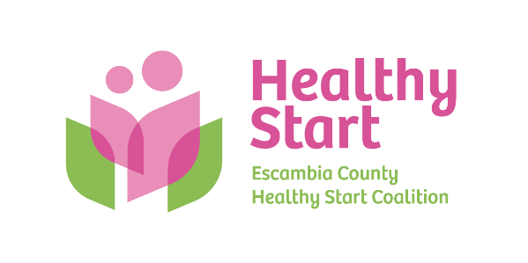
Escambia County Healthy Start Coalition Inc.,
318 N. Alcaniz Street | Pensacola Florida | 32501
P: 850-696-2291, F: 850-696-2551

Board of Directors

Meeting Minutes: June 19, 2025
Board Members Present: Rainey Brown, Margot Lauro, Kevin Driscoll, Janet Garrett, Judge Edward Nickinson, Dr. Rex Northup, Robin Wright, Diane Schwartz, Ander Shimek. (9 present). Attending via Zoom: None
Also Attending: Allyson Anderson, Barbara Shoulders (via Zoom)
Not Attending: Dr. Jaclyn Havinga, Russell Williams
- Call to order – Rainey called the meeting to order at 5:30 PM.
- Quorum (Requires 7/11 Current Members) – 9 Board members attended in-person. Quorum was established. Allyson informed the Board that Dr. Christine Krier resigned from the Board via email as she is relocating to Nashville, TN with her family.
- Mission Moment – Allyson presented Rex with special recognition for his many years of service to the Board. This was Rex’s last meeting, and thus the Board will have 10 members, inclusive of Dr. Krier’s resignation, unless/until additional members are brought aboard.
- Ratification of Minutes – The May 15, 2025 meeting minutes were reviewed by the Board and accepted as written.
- Board Business:
- Finance: May Financial Statements and Reports – Kevin presented the May 2025 financial statements and reports to the Board, noting that reimbursements are pending from Impact 100 and the Escambia Children’s Trust, while our April HSMN payment has just been received, further strengthening our financial position. Overall, expenses in most categories are as budgeted as we move toward the end of the fiscal year. No concerns noted and no questions from the Board.

- FIMR (CRT)/IMTF (CAG): In response to Margot’s request, a different staff member will attend for each Board meeting, beginning when the Board returns from summer break in August. Claire will be first in attendance in August, with staff rotating through April 2026 in order to introduce the staff and their work to the Board. In August, Claire will present more detailed FIMR CRT-CAG findings as our annual report is finalized and plans for a September gathering of the Escambia-based CRT take shape.

- Save the Date: Bow Ties & Tiaras – Thursday, October 2, 2025 at 5eleven from 5:30 PM – 8:00 PM. Margot provided an update on the work of the Bow Ties Committee, including plans underway to solicit sponsorships and asks by Board members. Edits to the sponsorship packets are now in progress and will be delivered to the Board next week.

- Executive Director Report:
  - Executive Director Performance Evaluation – The Executive Committee continues its work on Allyson’s performance evaluation, which is expected to be finalized at the August meeting.
  - IMPACT 100 Project Update – Allyson updated the Board on the execution of the Impact 100 van project, including full implementation of a weekly distribution schedule at 7 approved sites across Escambia County.
  - Escambia Children’s Trust – Execution is also underway, with purchase of all necessary equipment and supplies complete. Training and rollout among our providers is anticipated to begin within the next 60 days, once the initial phase of conversion to electronic prenatal screening is complete. This is occurring in 25% increments, with 25% OB onboarding completion each month, beginning in June, followed by additional 25% increments until 100% is reached by September 30, 2025.
  - Pops & Tots – Our first Fatherhood event of this kind was held at Bayview Park on Saturday, June 7 from 10:30 AM – 12:30 PM. We had a great response among our community partners, with 23 guests in attendance.

- New Business – (1) Committee to revisit Healthy Start Vision and Mission/Board Retreat: Diane, Kevin, and Robin will lead this effort. Scheduling to take place before the August Board meeting, Amy Remington and Ruthie Noel were suggested as facilitators - (2) Sunshine Law training – Allyson was able to confirm for the August 21 meeting, but it will be paused for rescheduling until new Board members are onboarded. Meredith Bush will be our expert presenter from Clark Partington.

- Adjourn – The meeting adjourned at 6:37 P.M.
- Next Meeting – Thursday, August 21, 2025 at 5:30 PM at the Healthy Start office.

