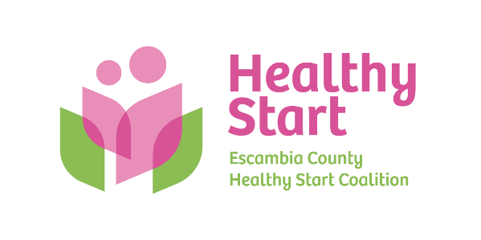
Escambia County Healthy Start Coalition Inc.,
318 N. Alcaniz Street | Pensacola Florida | 32501
P: 850-696-2291, F: 850-696-2551

Board of Directors Meeting Agenda

September 18, 2025
- Call to order
- Quorum (6/11 voting members)
- Welcome New Member – Beth Skarda, CPA
- Mission Moment – Allyson Anderson: Staff Appreciation For Performance Bonus/Keila - IMPACT 100 van at Bellview Library
- Acceptance of Minutes – August 21, 2025 Meeting Minutes
- Board Business:
- Finance: (1) June 30, 2025 Year-End (FINAL) and (2) August, 2025 Financial Statements & Reports; (3) Banking Proposal/Signatories - Kevin Driscoll
- FIMR/IMTF (Community Action Group: CAG) Updates – Allyson
- Bow Ties & Tiaras 2025 – Committee Update: Thursday, October 2, 2025, 5:30 PM – 8:00 PM @ 5eleven
- Board Membership – Dr. Julie DeCesare (Dr. Jaclyn Havinga)?
- Executive Director Report – Allyson Anderson

- Unfinished Business: (A) Committee to revisit Healthy Start Vision and Mission Scheduling; (B) Sunshine Law Training & Retreat Scheduling – Paused until new Board Members onboarded? Available Saturdays – September 6, September 13, September 27, October 11, October 18, October 25, November 1.

- Next Meeting: Thursday, October 16 @ 5:30 P.M.

- Adjourn

