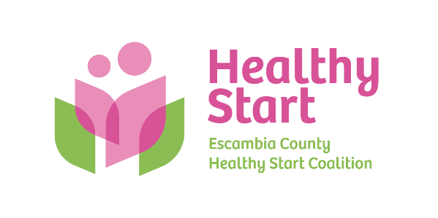
Escambia County Healthy Start Coalition Inc.,
318 N. Alcaniz Street | Pensacola Florida | 32501
P: 850-696-2291, F: 850-696-2551

Board of Directors Meeting Agenda

November 20, 2025

- Call to order
- Quorum (7/12 voting members)
- Welcome New Members – Beth Skarda, C.P.A. & Julie DeCesare, M.D. (Updated Roster)
- Mission Moment – Allyson Anderson
- Acceptance of Minutes – October 16, 2025 Meeting Minutes
- Board Business:
- Finance: October, 2025 Financial Statements & Reports - Kevin Driscoll
- FIMR/IMTF (Community Action Group: CAG) Updates – Allyson
- Bow Ties & Tiaras 2026 - 2026 Venue
- Executive Director Report – Allyson Anderson

- Unfinished Business: (A) Committee to revisit Healthy Start Vision and Mission Scheduling; (B) Sunshine Law Training & Retreat Scheduling – Has been held until new Board Members onboarded.

- Next Meeting: Thursday, January November 20, 2026 @ 5:30 P.M.

(NO DECEMBER MEETING for holiday break.)

- Adjourn

