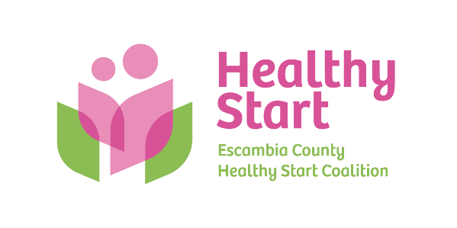
Escambia County Healthy Start Coalition Inc.,
318 N. Alcaniz Street | Pensacola Florida | 32501
P: 850-696-2291, F: 850-696-2551

Board of Directors

Meeting Minutes: March 19, 2026
Board Members Present: Margot Lauro, Kevin Driscoll, Robin Wright, Rainey Brown, Ander Shimek, Judge Nickinson, Dr. Jaclyn Havinga (7 present).
Also Attending in-Person: Allyson Anderson Attending via Zoom: Beth Skarda
Absent: Dr. Julie DeCesare, Russell Williams, Janet Garrett, Diane Schwartz
- Call to order – Margot called the meeting to order at 5:34 PM.
- Quorum (Requires 7/12 Current Members) – 7 Board members attended in-person. Quorum was established.
- Mission Moment – Allyson spoke with gratitude for the team’s perseverance and positivity throughout the challenges associated our case management system. The staff continues to go above and beyond to ensure client needs are met and services continue without interruption.
- Ratification of Minutes – Approval of the February 2026 Meeting Minutes, with motion and second by Ander and Kevin, respectively.
- Board Business:
- Finance: January 2026 Financial Statements and Reports – Kevin presented the February financial statements to the Board, noting anticipated financial stresses/unknowns in the months ahead, including case management data system failures and pending reallocation of state funds among all Coalitions. In addition, the Board extensively discussed our real estate needs and current pricing, with next steps being confirmation of renewal terms for our current location as well as identification of any options in the Town & Country vicinity prior to making a decision. In budgeting for FY 26-27, the Board expressed support for a preliminary 3% salary increase for staff, pending potential adjustments as our revenue outlook becomes more clear, while also supporting proposed migration of human resource services from Landrum to Avalon HR.
- FIMR (CRT)/IMTF (CAG): Allyson shared our February FIMR report and noted that Rep. Salzman’s task force will next meet on April 10, 2026, while our upcoming Service delivery report is in progress and will reflect recommendations from our FIMR CRT and other stakeholder interviews.
- Annual Fundraiser – Margot shared that Cocktails and Cradles preparations continue and fundraising efforts will also feature a limited number of silent auction items, including exceptional experiences that are expected to generate interest and donations. The sponsorship packet should be available at the next Board meeting for distribution.
- Executive Director Report: Held for the next meeting, although Allyson noted her handout that includes key items, including favorable HSMN site visit, leadership transition on FAHSC Board, and key upcoming event dates and deadlines. In addition, the Board approved updates to our Fiscal-Operating Policies and Procedures to ensure compliance with our DOH contract.
- Upcoming Dates/Events:
  - Saturday, April 18, 10:00 AM-1:00 PM – North Escambia Baby Shower @ Century Community Center

  - Thursday, May 21 Board Meeting, 5:30 PM – Vote on proposed FY 2026-2027 budget

  - Thursday, October 1, 5:30-8:00 PM – Cocktails & Cradles annual fundraiser @ 5eleven

  - Thursday, October 15, 6:00-7:00 PM – National Pregnancy & Infant Loss @ Bayview Park

  - Thursday, October 22, 4:30-6:30 PM – Trunk or Treat @ Alcaniz field space

- New Business – None
- Adjourn – The meeting adjourned at 7:12 P.M.
- Next Meeting – Thursday, April 16 at 5:30 PM at the Healthy Start office.

