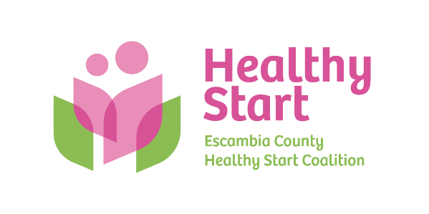
Escambia County Healthy Start Coalition Inc.,
318 N. Alcaniz Street | Pensacola Florida | 32501
P: 850-696-2291, F: 850-696-2551

Board of Directors

Meeting Minutes: February 19, 2026
Board Members Present: Margot Lauro, Janet Garrett, Kevin Driscoll, Russell Williams, Robin Wright, Diane Schwartz, Rainey Brown, Ander Shimek, Beth Skarda. (9 present).
Also Attending in-Person: Allyson Anderson Attending via Zoom: Barbara Shoulders
Absent: Dr. Julie DeCesare, Dr. Jaclyn Havinga, Judge Nickinson
- Call to order – Margot called the meeting to order at 5:30 PM and welcomed Guest Presenter, Meredith Bush, Esq.
- Quorum (Requires 7/12 Current Members) – 9 Board members attended in-person. Quorum was established.
- Mission Moment – Allyson spoke with gratitude for Kevin’s recent onsite training of Claire Kirchharr to help her better understand the Coalition’s financial statements and how to interpret them for appropriate stewardship. Allyson also expressed appreciation for the staff’s dedication, grace, and effort to manage the continuing challenges associated with the state Well Family System (WFS) to meet the needs of families we serve.
- Ratification of Minutes – Approval of the January 2026 Meeting Minutes held for the March meeting.
- Board Business:
- Sunshine Law Training – Guest Meredith Bush, Esq. made a presentation to the Board on its duties and obligations under Florida’s Sunshine Law. Please refer to her PowerPoint presentation for specific details. ACTION ITEM: Board members agreed to create separate personal email addresses to receive Healthy Start electronic correspondence for Sunshine Law/Open Records compliance. For example, allysonanderson.hs@gmail.com
- Finance: January 2026 Financial Statements and Reports – Kevin presented the January financial statements to the Board, with Allyson noting anticipated financial stresses in the months ahead, little of which are within our control. This is particularly so with the FAHSC data system (Well Family System or “WFS”) and continued transition to electronic screening, while also anticipating increased costs in key categories.
- FIMR (CRT)/IMTF (CAG): No Report. Held for March meeting.
- Annual Fundraiser – Margot shared that Cocktails and Cradles will require full Board support to secure sponsorships, with a fuller presentation to come at the March meeting.
- Executive Director Report: Held for March meeting, although Allyson noted her handout that includes key event dates and deadlines in this month’s meeting packet.
- Upcoming Dates/Events:
  - Saturday, April 18, 10:00 AM-1:00 PM – North Escambia Baby Shower @ Century Community Center

  - Thursday, May 21 Board Meeting, 5:30 PM – Vote on proposed FY 2026-2027 budget

  - Thursday, October 1, 5:30-8:00 PM – Cocktails & Cradles annual fundraiser @ 5eleven

  - Thursday, October 15, 6:00-7:00 PM – National Pregnancy & Infant Loss @ Bayview Park

  - Thursday, October 22, 4:30-6:30 PM – Trunk or Treat @ Alcaniz field space

- New Business – None
- Adjourn – The meeting adjourned at 6:39 P.M.
- Next Meeting – Thursday, April 16 at 5:30 PM at the Healthy Start office.

