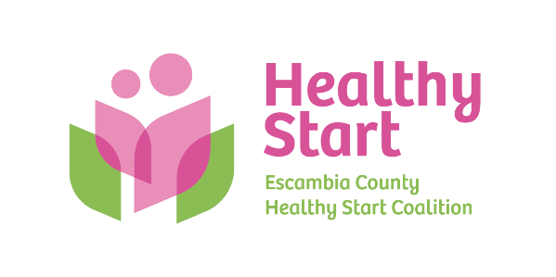
Escambia County Healthy Start Coalition Inc.,
318 N. Alcaniz Street | Pensacola Florida | 32501
P: 850-696-2291, F: 850-696-2551

Board of Directors

Meeting Minutes: October 16, 2025
Board Members Present: Margot Lauro, Kevin Driscoll, Janet Garrett, Robin Wright, Diane Schwartz, Dr. Jaclyn Havinga. (6 present). Attending via Zoom: None
Also Attending: Allyson Anderson, Jenn Regan, Barbara Shoulders
Not Attending: Beth Skarda, Julie DeCesare, Judge Nickinson, Rainey Brown, Russell Williams, Ander Shimek
- Call to order – Margot called the meeting to order at 5:31 PM.
- Quorum (Requires 6/11 Current Members) – 6 Board members attended in-person. Quorum was not established.
- Mission Moments – Allyson introduced Jenn Regan, our Business Manager, who shared her background and work at Healthy Start over the last 5+years. We thanked Jenn for assisting at Bow Ties with bartending duties when event staff were inadequate to meet needs.
- Ratification of Minutes – The September 18, 2025 meeting minutes were reviewed by the members present and accepted as written, with a motion to approve made by Janet and seconded by Kevin.
- Board Business:
- Finance: September, 2025 Financial Statements and Reports – Kevin presented the September financial statements and reports to the Board, noting that 3 months of DOH receivables of fixed monthly payments were due, but 2 of these 3 payments had been received this week – after the financials had been prepared. Allyson added that inquiries were made to our contract manager in Tallahassee who explained that recent short staffing resulted in lagging payments. No questions or concerns were asked or noted.

- FIMR (CRT)/IMTF (CAG): Allyson presented this month’s FIMR report as well as our Annual Report, with several Board members discussing Ohio subject matter expert Jill Miller’s recent appearance at CiviCon, her book. and the highly successful initiative to reduce infant mortality in Cincinnati. We are following up with inquiries to Rick Outzen, as well as attendance at Representative Michelle Salzman’s upcoming maternal health summit.

- Bow Ties & Tiaras – Margot, Janet, Diane, and Robin provided a high-level summary of our recent Bow Ties event. After expenses, it was noted that we raised a net income of $44,456, nearly a $10,000 increase over last year. Allyson will follow up to confirm whether Representative Salzman received an invitation.

- Executive Director Report:
- North Escambia Stork Stock – CHNWF move in date is October 21. Ceremonial re-opening plans are in progress.
- IMPACT 100 – Implementation is on track and completed Quarter 2 inventory purchase.
- Escambia Children’s Trust – Implementation also on track with provider tablet training in progress and meeting all project milestones.
- PSC Non-Profit Certification Program – No update at this time. Allyson will follow up for immediate assistance with Mission and Vision consulting services. To be followed up with Board retreat.
- Events:
- Car Seat Event at Coalition office, 09/26/25 - 18 car seats installed.
- NPIL, 10/14/25 at Bayview Park Community Center – 4 families served.
- Trunk or Treat, 10/23/25 at Coalition office (5:00 PM – 7:00 PM)
- 2026 North Escambia Baby Shower – Saturday, April 18, 2026 (Century Community Center)
- Staff Attendance at Board Meetings – 11/20 - Chris; 01/15 - Tabatha; 03/19 - Jade; 04/16 - Megan

- New Business – (1) Sunshine Law training – Paused for rescheduling until new Board members are fully onboarded. Meredith Bush will be our expert presenter.

- Adjourn – The meeting adjourned at 6:42 P.M.
- Next Meeting – Thursday, November 20, 2025 at 5:30 PM at the Healthy Start office.

