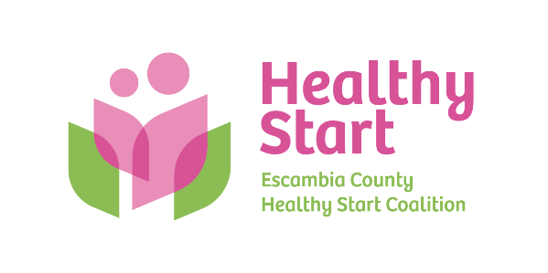
Escambia County Healthy Start Coalition Inc.,
318 N. Alcaniz Street | Pensacola Florida | 32501
P: 850-696-2291, F: 850-696-2551

Board of Directors Meeting Agenda

August 21, 2025

- Call to order
- Quorum (6/10 voting members)
- Mission Moment – Allyson Anderson
- Acceptance of Minutes – June 19, 2025 Meeting Minutes
- Board Business:
- Finance: (1) June 30, 2025 Year-End and (2) July 2025 Financial Statements & Reports; (3) Regions Bank CD Renewal: 13 months @ 3.68% - Kevin Driscoll
- FIMR/IMTF (Community Action Group: CAG) Updates – Claire Kirchharr
- Bow Ties & Tiaras 2025 – Committee Update: Thursday, October 2, 2025, 5:30 PM – 8:00 PM @ 5eleven
- Board Membership – Dr. Julie DeCesare (Dr. Jaclyn Havinga), Ms. Beth Skarda, Saltmarsh, Cleaveland, & Gund (Janet Garrett)
- Executive Director Performance Evaluation & Job Description – Executive Committee
- Executive Director Report – Allyson Anderson
- Unfinished Business: (A) Committee to revisit Healthy Start Vision and Mission Scheduling; (B) Sunshine Law Training & Retreat Scheduling – Paused until new Board Members onboarded? Available Saturdays – August 30 (Labor Day weekend), September 6, September 13, September 27, October 11, October 18, October 25, November 1.

- Next Meeting: Thursday, September 18 @ 5:30 P.M.

- Adjourn

