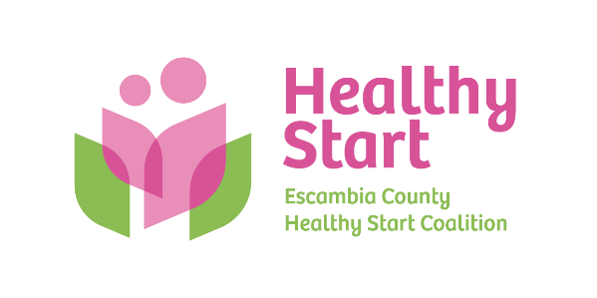
Escambia County Healthy Start Coalition Inc.,
318 N. Alcaniz Street | Pensacola Florida | 32501
P: 850-696-2291, F: 850-696-2551

Board of Directors Meeting Agenda

April 16, 2026

- Call to order
- Quorum (7/12 voting members)
- Mission Moment – Allyson Anderson
- Acceptance of Minutes – March 19, 2026 Meeting Minutes
- Board Business:
- Finance: (1) March Financial Statements & Reports; (2) Case Management System – Revenue Impacts; (3) FY 2026-2027 Budget Update, including Lease - Kevin Driscoll
- FIMR/IMTF (Community Action Group: CAG) Updates – Allyson Anderson
- Cocktails For Cradles – Margot & Event Committee
- Bylaws Committee Update – Judge Nickinson & Committee
- Executive Director Report – Allyson Anderson
- Retreat Summary and Next Steps – Margot Lauro

- Next Meeting: Thursday, May 21, 2026 @ 5:30 P.M.

- Adjourn

