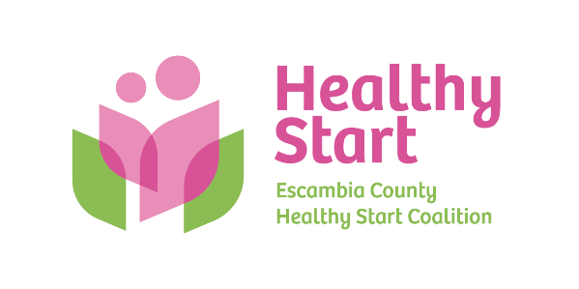
Escambia County Healthy Start Coalition Inc.,
318 N. Alcaniz Street | Pensacola Florida | 32501
P: 850-696-2291, F: 850-696-2551

Board of Directors

Meeting Minutes: August 21, 2025
Board Members Present: Margot Lauro, Kevin Driscoll, Rainey Brown, Judge Edward Nickinson, Robin Wright, Ander Shimek. (6 present). Attending via Zoom: None
Also Attending: Allyson Anderson, Barbara Shoulders (via Zoom)
Not Attending: Dr. Jaclyn Havinga, Russell Williams, Diane Schwartz, Janet Garrett

- Call to order – Margot called the meeting to order at 5:53 PM.
- Quorum (Requires 6/10 Current Members) – 6 Board members attended in-person. Quorum was established.
- Mission Moment – Claire shared our recent success with a TEAM Dad client of Chris’s and the 3 car seats he received from the Coalition that will enable him to have visits with his young children.
- Ratification of Minutes – The June 19, 2025 meeting minutes were reviewed by the Board and accepted as written.
- Board Business:
- Finance: June & July Draft Financial Statements and Reports – Kevin presented the June and July 2025 draft financial statements and reports to the Board, noting that the year-end financials for June will be finalized once recent payments from HSMN/Medicaid, DOH, and our contingency payout are recorded. It is expected that we will finish out the last fiscal year overall on budget, and solidly in the black. No concerns noted.

Significant challenges with the recent merger of The First with Renasant Bank were discussed, spanning over two weeks. These issues are now resolved but it resulted in loss of confidence and trust with our bank. Allyson will be scouting for a new primary bank for our operating account. Once the Board approves a specific new bank selection, new signatories must meet at the new bank to open our account and execute a signature card. Finally, we renewed our CD with Regions Bank at an interest rate of 3.68% and a new maturity date of 08/06/2026.

- FIMR (CRT)/IMTF (CAG): Claire presented this month’s FIMR report and also invited Board members to attend our upcoming Escambia CRT meeting on Tuesday, September 16 at 9:00 AM at the Coalition office. Claire reported that we are seeing the 1st significant decline in mortality rates in many years, and are enthusiastically awaiting final published reports to confirm this.
- Bow Ties & Tiaras – Thursday, October 2, 2025 at 5eleven from 5:30 PM – 8:00 PM. Margot and Robin provided an update on the work of the Bow Ties Committee, including the current status of sponsorships ($18,000 received and/or committed).
- Board Membership – Beth Skarda, CPA with Saltmarsh, Cleaveland, and Gunn was voted on the Board, with Ander making the motion and Judge Nickinson seconding the motion. No action taken on Dr. Havinga’s recommendation of Dr. Julie DeCesare as she was not in attendance.
- Executive Director Performance Evaluation – The Board presented Allyson with her written performance evaluation and goals for the new fiscal year. A 3% merit increase was approved.
- Executive Director Report:
- DOH Department of Financial Services – Site visit September 2-3.
- Updated Org Chart – Provided to Board.
- Human Resources – The Board authorized a one-time bonus for performance payment to all staff, excluding Allyson, in the amount of $1,250 per person for our 6 employees.
- TEAM Dad – Graduation, 1:00 PM, Wednesday, 09/03/25 at Library (Spring Street)
- West Florida Hospital - $500 baby shower receivable aged since April.
- North Escambia Stork Stock – CHNWF move in progress. New target of September for completion.
- IMPACT 100 – Implementation is on track and moving forward with Quarter 2 inventory purchase.
- Escambia Children’s Trust – Implementation also on track with provider tablet training in progress and meeting all project milestones.
- Storage Solutions – The Board authorized moving forward with storage unit rental rather than purchase of a more permanent on-site storage shed.
- PSC Non-Profit Certification Program – The Board approved proceeding with the previously unbudgeted cost of PSC’s Non-Profit Certification program, with our participants including Board members and staff.
- Electronic Screening Update – Allyson reported that we have achieved registration of all Escambia providers well ahead of statewide deadlines: 25% completion by June 30, 50% completion as of July 31, 75% by August 31, and 100% by September 30.
- Future Events:
- Fatherhood Graduation, 1:00 PM on 09/03/25 at Pensacola Library/Spring Street location
- FIMR Open House – 9:00 AM 09/16/25 at Coalition office
- Car Seat Event at Coalition office, 09/26/25 (9:00 AM – 12:00 PM)
- NPIL, 10/14/25 at Bayview Park
- Trunk or Treat, 10/23/25 at Coalition office (5:00 PM – 7:00 PM)
- 2026 North Escambia Baby Shower – Date TBD, April 2026 (Century Community Center)
- Staff Attendance at Board Meetings – 08/21 - Claire; 09/18 - Keila; 10/16 - Jenn; 11/20 - Chris; 01/15 - Tabatha; 03/19 - Jade; 04/16 - Megan

- New Business – (1) Committee to revisit Healthy Start Vision and Mission/Board Retreat: Diane, Kevin, and Robin will lead this effort. (2) Sunshine Law training – Allyson was able to confirm for the August 21 meeting, but both # 1 and Sunshine training are paused for rescheduling until new Board members are onboarded. Meredith Bush will be our expert presenter.

- Adjourn – The meeting adjourned at 7:17 P.M.
- Next Meeting – Thursday, September 18, 2025 at 5:30 PM at the Healthy Start office.

